**Project** **Documentation**

**Project Title: InsightStream – Navigate the News Landscape**

**Team ID:** NM2025TMID36463

**Team Leader:** VAISHNAVI P – [24csvaishnavip105@gmail.com](mailto:24csvaishnavip105@gmail.com)

**Team Members:**

SEETHA E – [24csseethae091@gmail.com](mailto:24csseethae091@gmail.com)

SUCHITRA L – [24cssujitha098@gmail.com](mailto:24cssujitha098@gmail.com)

SIREEN FATHIMA K – [24cssireenfathima094@gmail.com](mailto:24cssireenfathima094@gmail.com)

SUJITHA T – [24cssujitha099@gmail.com](mailto:24cssujitha099@gmail.com)

**1. Project Overview :**

* InsightStream is a platform to help users explore, analyze, and personalize news content from Multiple sources, offering curated feeds, topic clustering, and sentiment insights.

**Features**:

• Aggregated news from multiple sources

• Topic-wise categorization and search

• Personalized recommendations

• Real-time updates and notifications

• Admin dashboard to manage sources

**2.Architecture :**

* Frontend: React.js with Bootstrap / Material UI
* Backend: Node.js & Express.js handling server logic and API endpoints
* Database: MongoDB storing user profiles, news articles, preferences, and analytics

**3.Setup Instructions:**

Prerequisites: Node.js, MongoDB, Git, React.js, Express.js, Mongoose, Visual Studio Code

*Installation Steps:*

1. Clone the repository: git clone
2. Install client dependencies: cd client && npm install
3. Install server dependencies: cd ../server && npm install

**4.Folder Structure :**

InsightStream/

├── client/ # React frontend

│ ├── components/

│ └── pages/

├── server/ # Node.js backend

│ ├── routes/

│ ├── models/

│ └── controllers/

**5.Running the Application:**

Frontend: cd client && npm start

Backend: cd server && npm start

Access: Visit <http://localhost:3000>

**6.API Documentation:**

*Users*: POST /api/user/register, POST /api/user/login

*News*: GET /api/news, GET /api/news/:id, POST /api/news/save

*Preferences*: GET /api/preferences, POST /api/preferences

**7.Authentication**:

JWT-based authentication for secure login. Middleware to protect private routes.

**8:User Interface :**

• Landing Page with trending news

• Topic-wise News Dashboard

• Personalized Recommendations

• Admin Panel

**9.Testing:**

Manual testing at each milestone. Tools: Postman, Chrome Dev Tools

**10.Screenshots :**

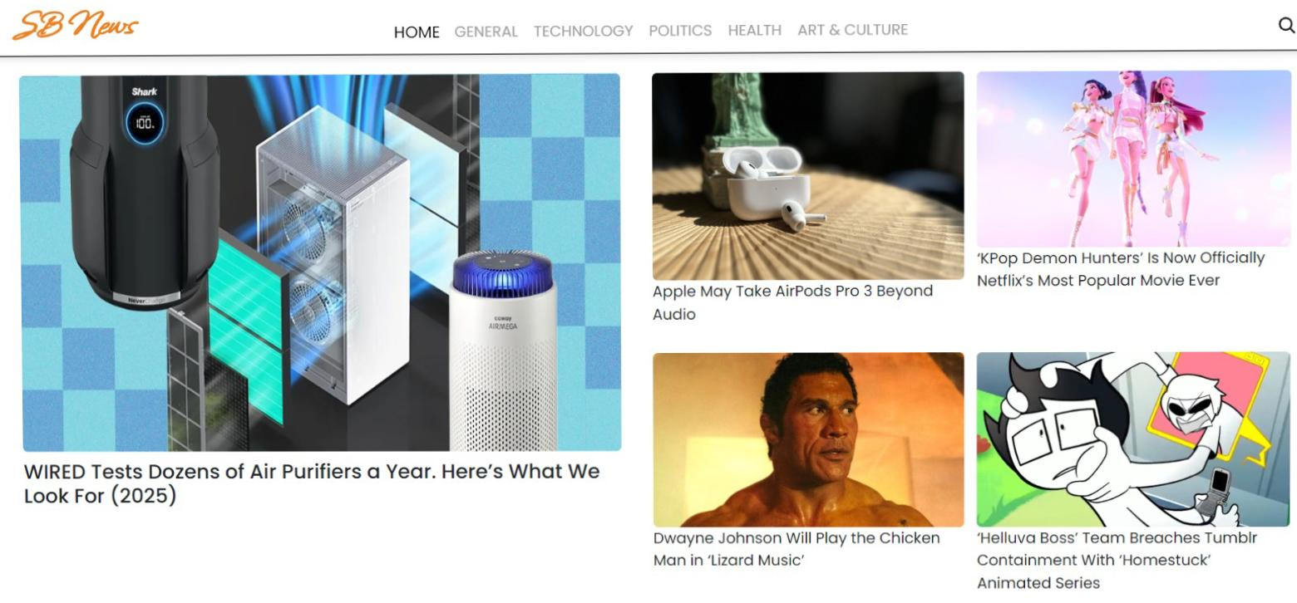

* <https://drive.google.com/file/d/1IaS6PTKqOCUkwvHNKxFa_clGEI3FK70W/view?usp=drivesdk>

**11.Issues:**

• Limited number of news sources integrated at present.

• Personalization algorithm still in beta stage; recommendations may not be fully accurate.

• Mobile responsiveness needs improvements on smaller devices.

• Real-time notifications may have delays under heavy load.

• Analytics dashboard not fully implemente.

**12.Future Enhancements:**

• Add more international and regional news sources.

• Improve AI-based personalization.

• Develop dedicated mobile app.

• Enable multilingual content

**12.Conclusion :**

* InsightStream – Navigate the News Landscape offers a simple, unified way for users to access and explore news from multiple sources. This documentation summarizes its features, setup, issues and planned upgrades, providing a clear base for future improvements.